The Fifteenth Sunday after Pentecost  Proper 19 | Sunday, September 17, 2017
Welcome to
THE CHURCH OF THE EPIPHANY
Royersford, PA

A friendly welcome to all! If you are visiting, please fill out a visitor’s card
and place it in the offertory plate or give it to an usher.
We hope you’ll join us for refreshments and fellowship after worship today.
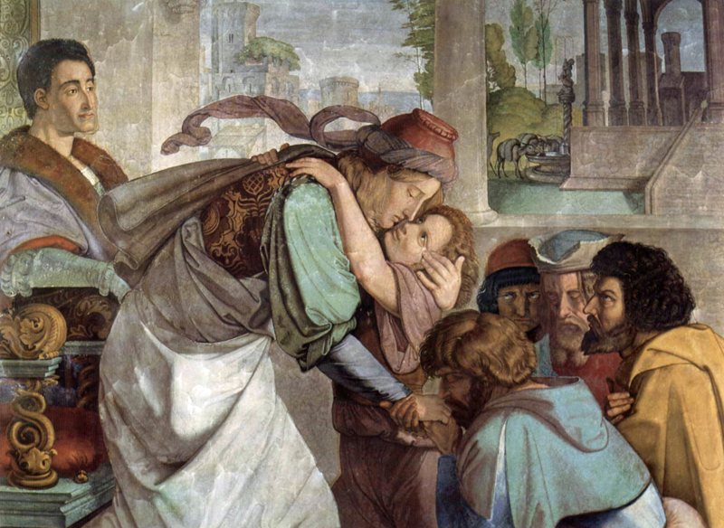

Liturgy of the Word

Entrance Hymn 400 (1,4-5,7)
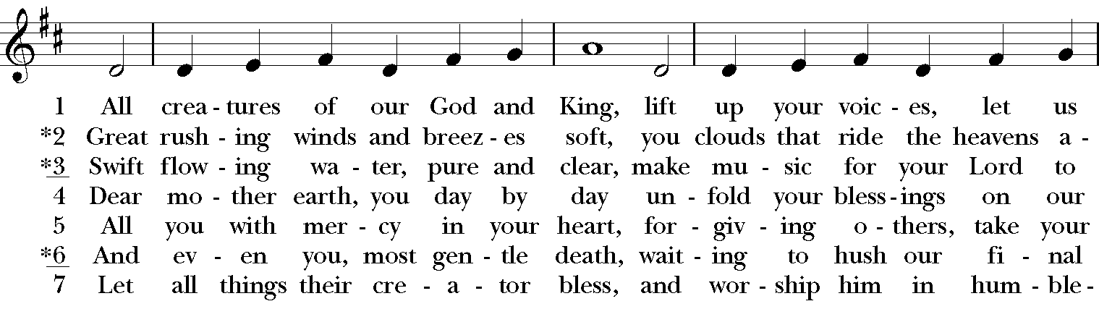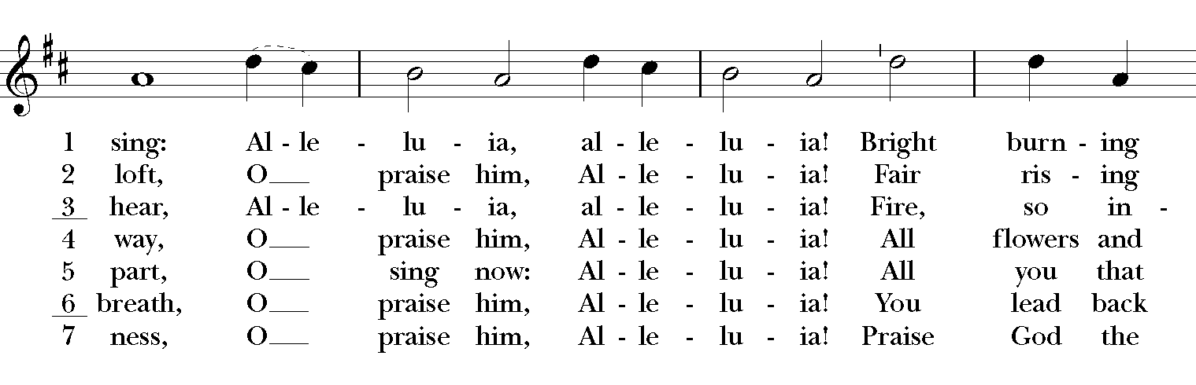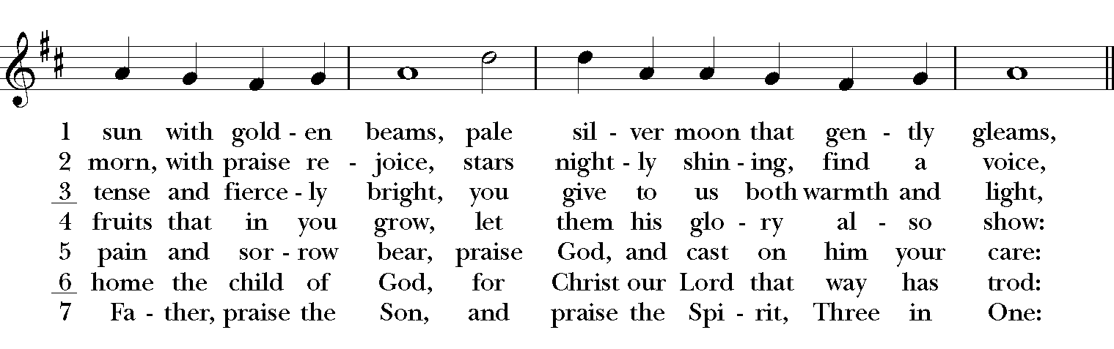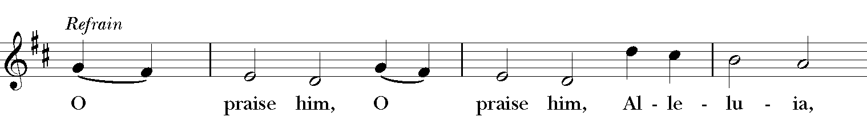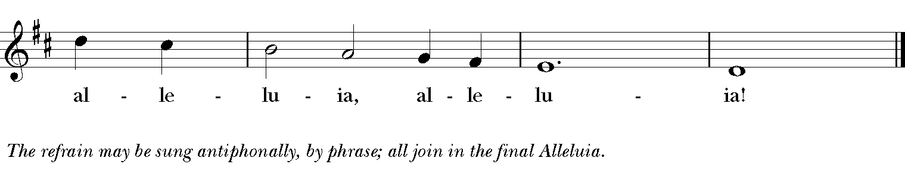
All stand as able
Presider | Blessed be God: Father, Son, and Holy Spirit.
People | And blessed be God’s kingdom, now and forever.
 | Amen.

The Presider and People
Almighty God, to you all hearts are open, all desires known, and from you no secrets are hid: Cleanse the thoughts of our hearts by the inspiration of your Holy Spirit, that we may perfectly love you, and worthily magnify your holy Name; through Christ our Lord. Amen.
The following is sung, all standing
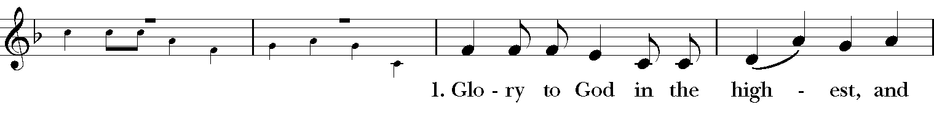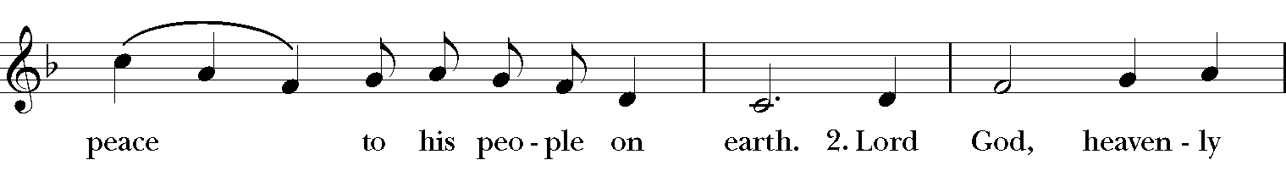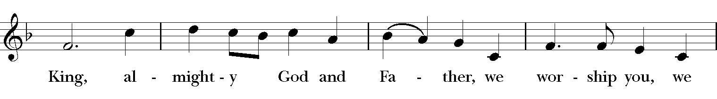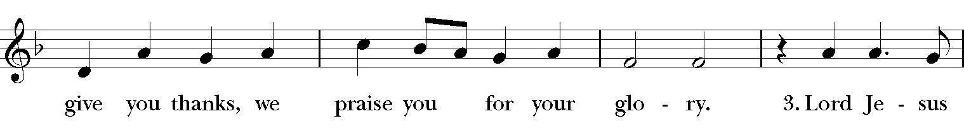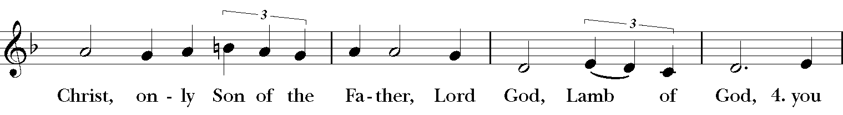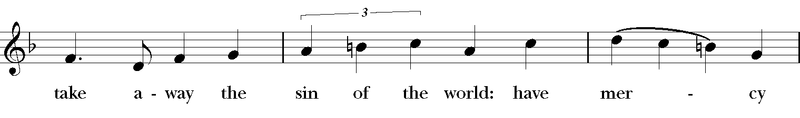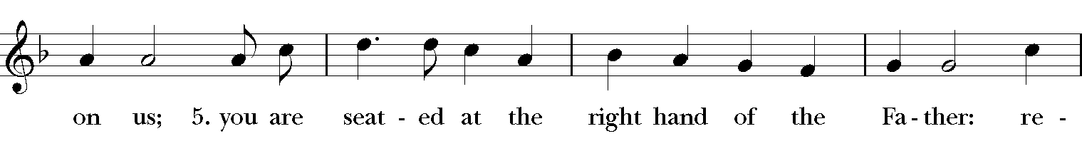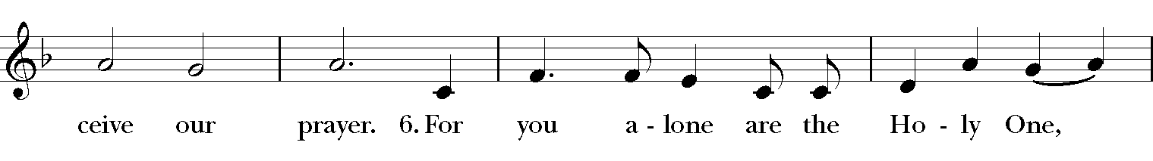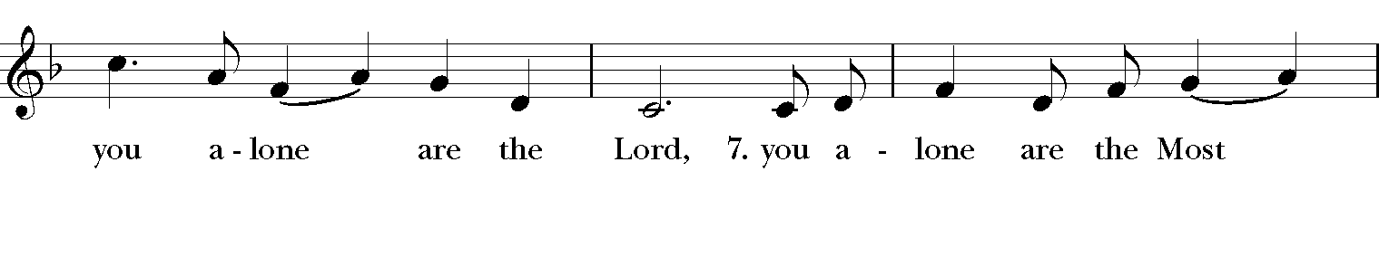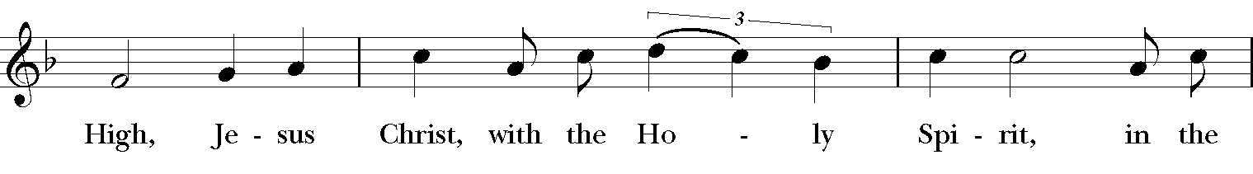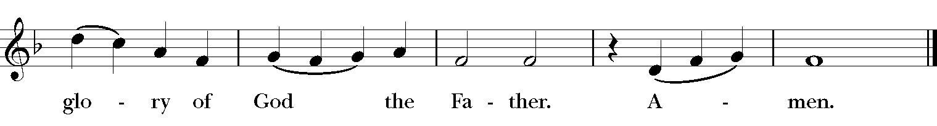
The Collect of the Day
Presider | The Lord be with you.
People | And also with you.
Presider | Let us pray.

O God, because without you we are not able to please you, mercifully grant that your Holy Spirit may in all things direct and rule our hearts; through Jesus Christ our Lord, who lives and reigns with you and the Holy Spirit, one God, now and for ever. Amen.
The First Reading | Genesis 50:15-21
All are seated
A Reading from the book of Genesis.
Realizing that their father was dead, Joseph’s brothers said, “What if Joseph still bears a grudge against us and pays us back in full for all the wrong that we did to him?” So they approached Joseph, saying, “Your father gave this instruction before he died, ‘Say to Joseph: I beg you, forgive the crime of your brothers and the wrong they did in harming you.’ Now therefore please forgive the crime of the servants of the God of your father.” Joseph wept when they spoke to him. Then his brothers also wept, fell down before him, and said, “We are here as your slaves.” But Joseph said to them, “Do not be afraid! Am I in the place of God? Even though you intended to do harm to me, God intended it for good, in order to preserve a numerous people, as he is doing today. So have no fear; I myself will provide for you and your little ones.” In this way he reassured them, speaking kindly to them.
Reader The Word of the Lord
People Thanks be to God

Psalm 103:(1-7), 8-13
1 [Bless the Lord, O my soul, *
and all that is within me, bless his holy Name.
2 Bless the Lord, O my soul, *
and forget not all his benefits.
3 He forgives all your sins *
and heals all your infirmities;
4 He redeems your life from the grave *
and crowns you with mercy and loving-kindness;
5 He satisfies you with good things, *
and your youth is renewed like an eagle's.
6 The Lord executes righteousness *
and judgment for all who are oppressed.
7 He made his ways known to Moses *
and his works to the children of Israel.]
8 The Lord is full of compassion and mercy, *
slow to anger and of great kindness.
9 He will not always accuse us, *
nor will he keep his anger for ever.
10 He has not dealt with us according to our sins, *
nor rewarded us according to our wickedness.
11 For as the heavens are high above the earth, *
so is his mercy great upon those who fear him.
12 As far as the east is from the west, *
so far has he removed our sins from us.
13 As a father cares for his children, *
so does the Lord care for those who fear him.

The Second Reading | Romans 14:1-12
A Reading from Paul’s letter to the Church in Rome.
Welcome those who are weak in faith, but not for the purpose of quarreling over opinions. Some believe in eating anything, while the weak eat only vegetables. Those who eat must not despise those who abstain, and those who abstain must not pass judgment on those who eat; for God has welcomed them. Who are you to pass judgment on servants of another? It is before their own lord that they stand or fall. And they will be upheld, for the Lord is able to make them stand.
Some judge one day to be better than another, while others judge all days to be alike. Let all be fully convinced in their own minds. Those who observe the day, observe it in honor of the Lord. Also those who eat, eat in honor of the Lord, since they give thanks to God; while those who abstain, abstain in honor of the Lord and give thanks to God.
We do not live to ourselves, and we do not die to ourselves. If we live, we live to the Lord, and if we die, we die to the Lord; so then, whether we live or whether we die, we are the Lord's. For to this end Christ died and lived again, so that he might be Lord of both the dead and the living. Why do you pass judgment on your brother or sister? Or you, why do you despise your brother or sister? For we will all stand before the judgment seat of God. For it is written, "As I live, says the Lord, every knee shall bow to me, and every tongue shall give praise to God." So then, each of us will be accountable to God.
Reader | The Word of the Lord.
People | Thanks be to God.

Sequence Hymn 674
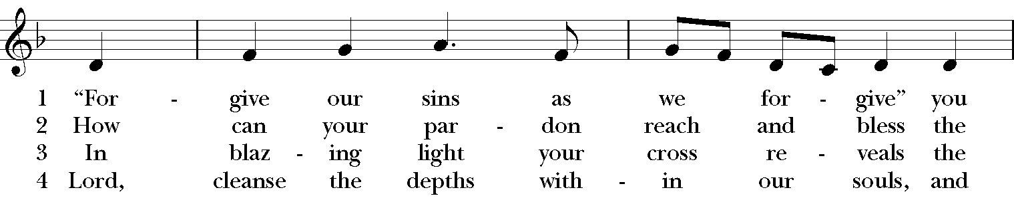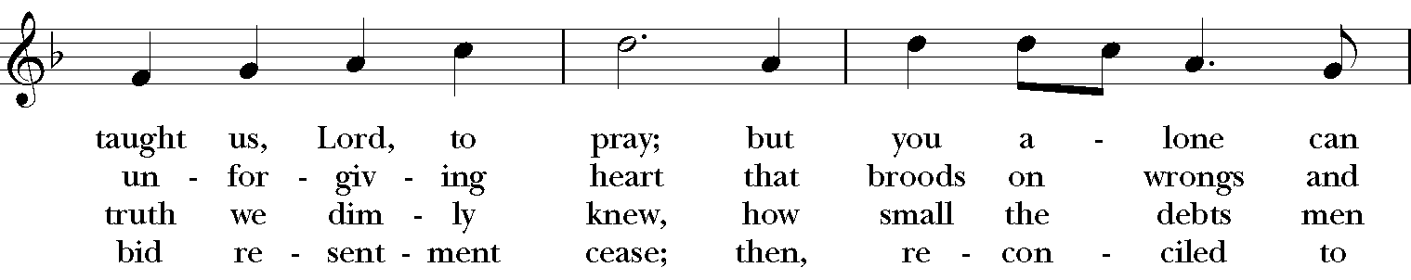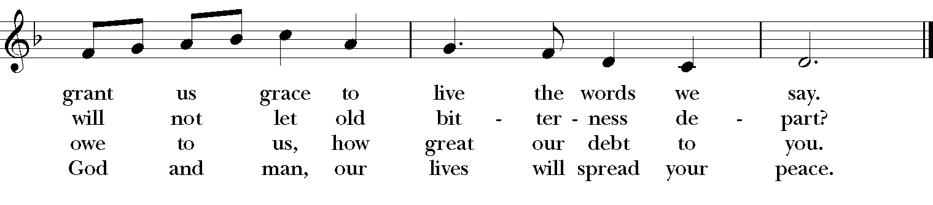
All stand as able
The Holy Gospel | Matthew 18:21-35
All stand.
Priest | The Holy Gospel of our Lord Jesus Christ according to Matthew.
People | Glory to you, Lord Christ.

Peter came and said to Jesus, “Lord, if another member of the church sins against me, how often should I forgive? As many as seven times?” Jesus said to him, “Not seven times, but, I tell you, seventy-seven times.
“For this reason the kingdom of heaven may be compared to a king who wished to settle accounts with his slaves. When he began the reckoning, one who owed him ten thousand talents was brought to him; and, as he could not pay, his lord ordered him to be sold, together with his wife and children and all his possessions, and payment to be made. So the slave fell on his knees before him, saying, ‘Have patience with me, and I will pay you everything.’ And out of pity for him, the lord of that slave released him and forgave him the debt. But that same slave, as he went out, came upon one of his fellow slaves who owed him a hundred denarii; and seizing him by the throat, he said, ‘Pay what you owe.’ Then his fellow slave fell down and pleaded with him, ‘Have patience with me, and I will pay you.’ But he refused; then he went and threw him into prison until he would pay the debt. When his fellow slaves saw what had happened, they were greatly distressed, and they went and reported to their lord all that had taken place. Then his lord summoned him and said to him, ‘You wicked slave! I forgave you all that debt because you pleaded with me.
Should you not have had mercy on your fellow slave, as I had mercy on you?’ And in anger his lord handed him over to be tortured until he would pay his entire debt. So my heavenly Father will also do to every one of you, if you do not forgive your brother or sister from your heart.”
Priest | The Gospel of the Lord.
People | Praise to you, Lord Christ.
The Homily

The Nicene Creed

All stand.

We believe in one God, the Father, the Almighty, maker of heaven and earth, of all that is seen and unseen. We believe in one Lord, Jesus Christ, the only Son of God, eternally begotten of the Father, God from God, Light from Light, true God from true God, begotten, not made, of one Being with the Father. Through him all things were made. For us and for our salvation he came down from heaven: by the power of the Holy Spirit he became incarnate from the Virgin Mary, and was made man. For our sake he was crucified under Pontius Pilate; he suffered death and was buried. On the third day he rose again in accordance with the Scriptures; he ascended into heaven and is seated at the right hand of the Father. He will come again in glory to judge the living and the dead, and his kingdom will have no end. We believe in the Holy Spirit, the Lord, the giver of life, who proceeds from the Father and the Son. With the Father and the Son he is worshiped and glorified. He has spoken through the Prophets. We believe in one holy catholic and apostolic Church. We acknowledge one baptism for the forgiveness of sins. We look for the resurrection of the dead, and the life of the world to come. Amen.

Prayers of the People

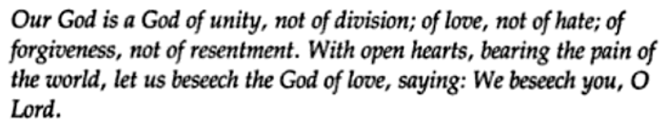

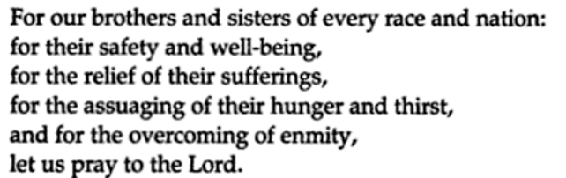

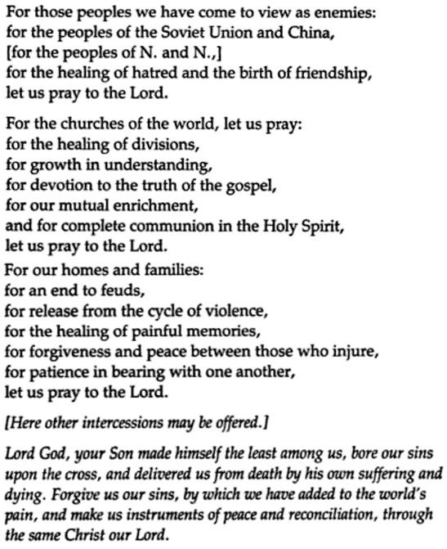

Birthdays: 18 - Andrew Garone 19 - Paul Exley 23 - Charles Dell
Anniversaries: 20 - Vincent & Susan Garone
Altar Flowers: Given to celebrate my daughter, Rebecca's upcoming Birthday and God's gift of autumn in all its Glory! by Vicki Cox and Family
Given in loving memory of Courtney Elizabeth Hudson who passed away on August 5, 2017 by, dad, Robert and step-mother, Margaret Hudson. May you rest In peace.

Confession of Sin
Let us confess our sins against God and our neighbor.
Silence.
Minister and People
Most merciful God, we confess that we have sinned against you in thought, word, and deed,
by what we have done, and by what we have left undone. We have not loved you with our whole
heart; we have not loved our neighbors as ourselves. We are truly sorry and we humbly repent.
For the sake of your Son Jesus Christ, have mercy on us and forgive us; that we may delight in your
will, and walk in your ways, to the glory of your Name. Amen.

The Priest stands and says
Almighty God have mercy on you, forgive you all your sins through our Lord Jesus Christ, strengthen you in all goodness, and by the power of the Holy Spirit keep you in eternal life. Amen.

Peace
All stand.
Presider | The peace of the Lord be always with you.
People | And also with you.

The People greet one another in the name of the Lord.

The Liturgy of the Table
Offertory Sentence and Hymn

Offertory Hymn 390
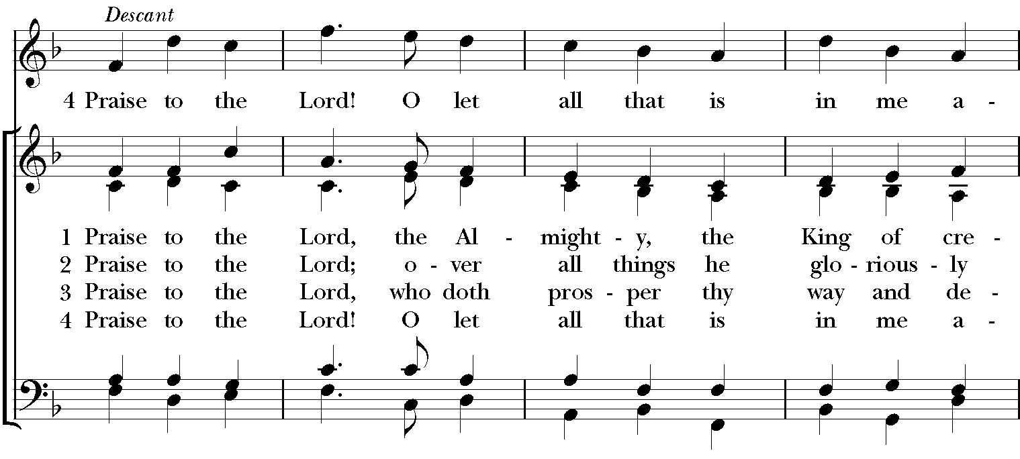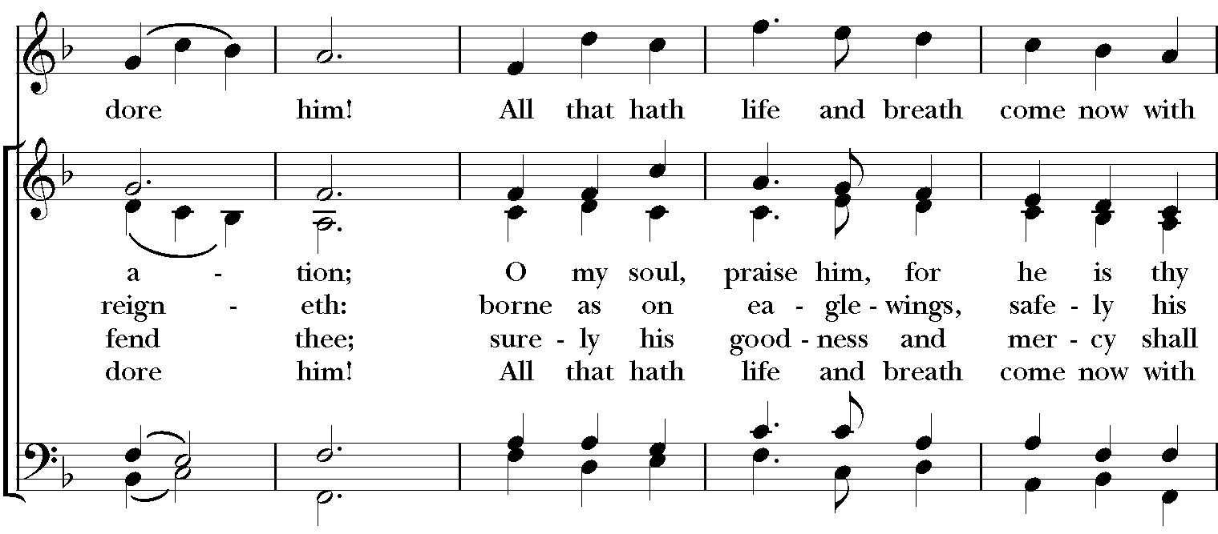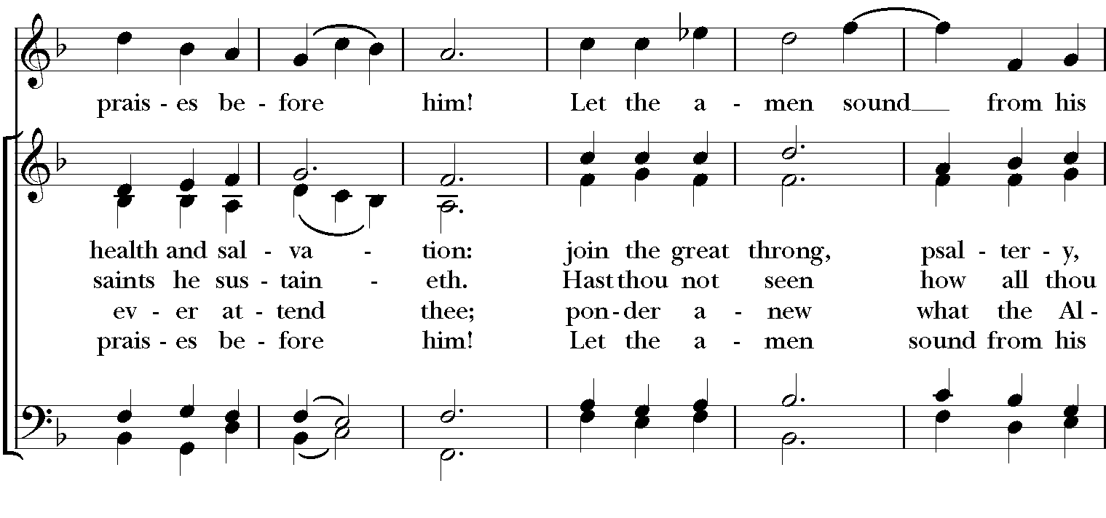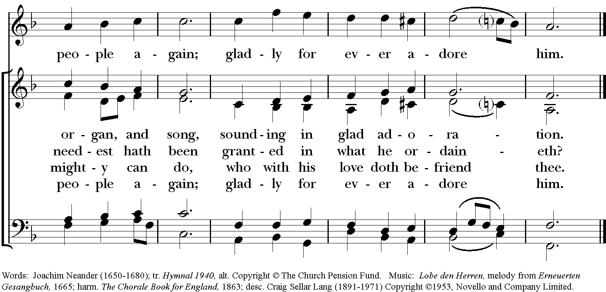

At the presentation of the Offering:

Praise God, from whom all blessings flow;

Praise God, all creatures here below;

Praise God above, ye heavenly host:

Praise Father, Son, and Holy Ghost. Amen.

The Great Thanksgiving
The people remain standing.
Presider | The Lord be with you.
People | And also with you.
Presider | Lift up your hearts.
People | We lift them to the Lord.
Presider | Let us give thanks to the Lord our God.
People | It is right to give thanks and praise.

The Presider proceeds
It is right, and a good and joyful thing, always and everywhere to give thanks to you, Father Almighty, Creator of heaven and earth. For you are the source of light and life; you made us in your image, and called us to new life in Jesus Christ our Lord.
Therefore we praise you, joining our voices with Angels and Archangels and with all the company of heaven, who forever sing this hymn to proclaim the glory of your Name:
Sanctus
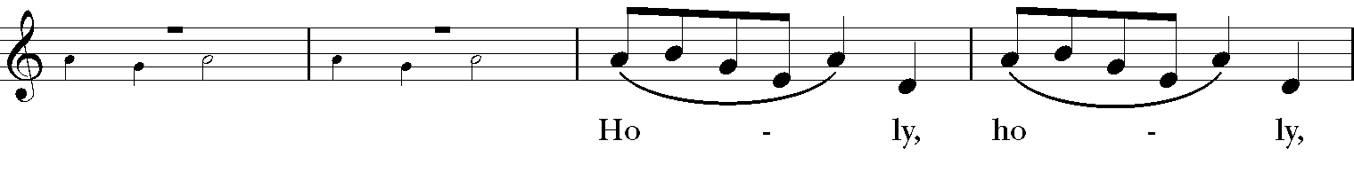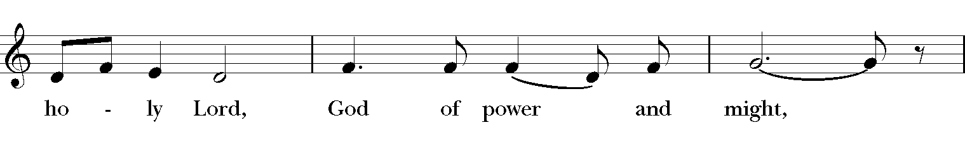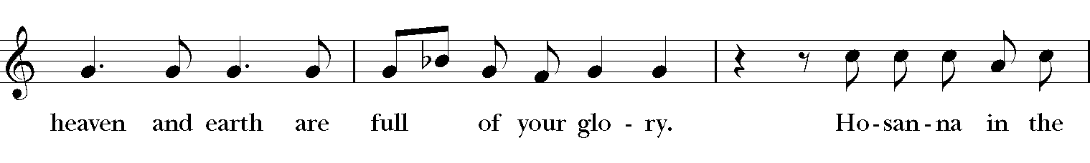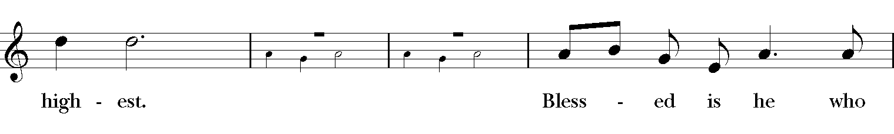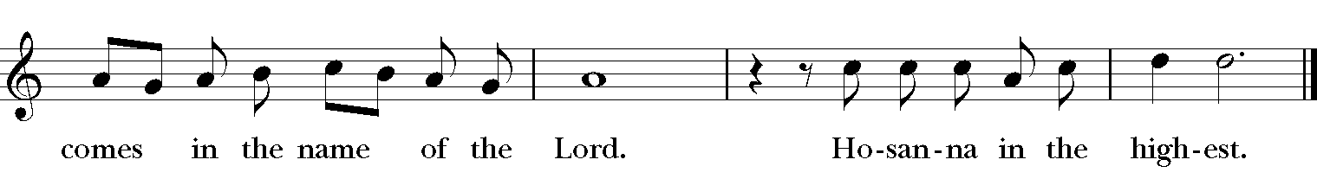
The Presider continues
Holy and gracious Father: In your infinite love you made us for yourself; and, when we had fallen into sin and become subject to evil and death, you, in your mercy, sent Jesus Christ, your only and eternal Son, to share our human nature, to live and die as one of us, to reconcile us to you, the God and Father of all.
He stretched out his arms upon the cross, and offered himself in obedience to your will, a perfect sacrifice for the whole world.
On the night he was handed over to suffering and death, our Lord Jesus Christ took bread; and when he had given thanks to you, he broke it, and gave it to his disciples, and said, “Take, eat: This is my Body, which is given for you. Do this for the remembrance of me.”
After supper he took the cup of wine; and when he had given thanks, he gave it to them, and said, “Drink this, all of you: This is my Blood of the new Covenant, which is shed for you and for many for the forgiveness of sins. Whenever you drink it, do this for the remembrance of me.”
Therefore we proclaim the mystery of faith:
Presider and People
Christ has died.
Christ is risen.
Christ will come again.

The Presider continues
We celebrate the memorial of our redemption, O Father, in this sacrifice of praise and thanksgiving. Recalling his death, resurrection, and ascension, we offer you these gifts. Sanctify them by your Holy Spirit to be for your people the Body and Blood of your Son, the holy food and drink of new and unending life in him. Sanctify us also that we may faithfully receive this holy Sacrament, and serve you in unity, constancy, and peace; and at the last day bring us with all your saints into the joy of your eternal kingdom.
All this we ask through your Son Jesus Christ. By him, and with him, and in him, in the unity of the Holy Spirit all honor and glory is yours, Almighty Father, now and for ever. AMEN.

The Presider continues
As our Savior Christ has taught us, we now pray
Our Father, who art in heaven, hallowed be thy Name, thy kingdom come, thy will be done, on earth as it is in heaven. Give us this day our daily bread. And forgive us our trespasses, as we forgive those who trespass against us. And lead us not into temptation, but deliver us from evil. For thine is the kingdom, and the power, and the glory, for ever and ever. Amen.

The Breaking of the Bread
A period of silence is kept.
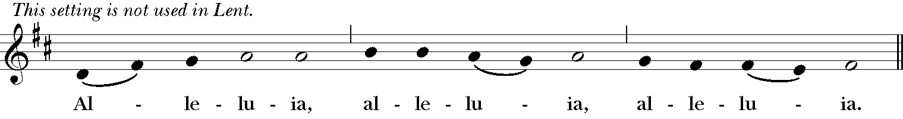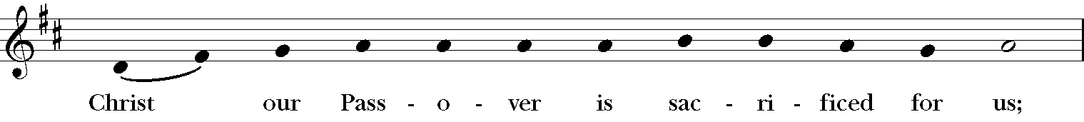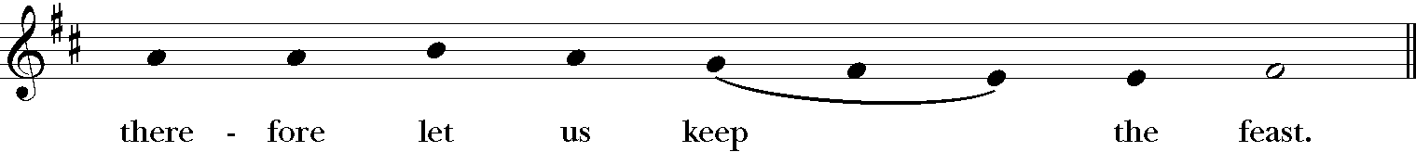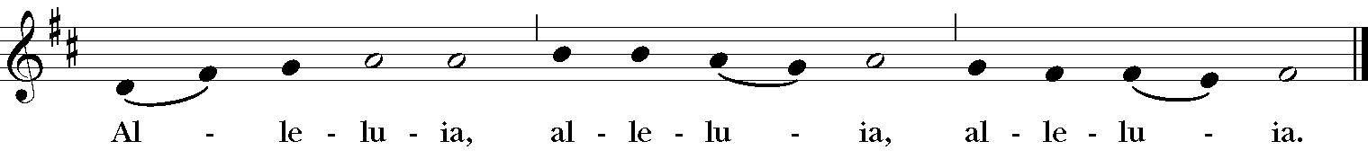
The Invitation to Holy Communion
The Gifts of God for the People of God
This is the Lord's Table, God's feast for all of God's people. There is always Abundance here and a place for you. You are invited and encouraged to join us at the altar rail.
If you wish to receive a blessing instead of the bread or wine, you are welcome;
please come forward and cross your arms over your chest.

Communion Hymns 516
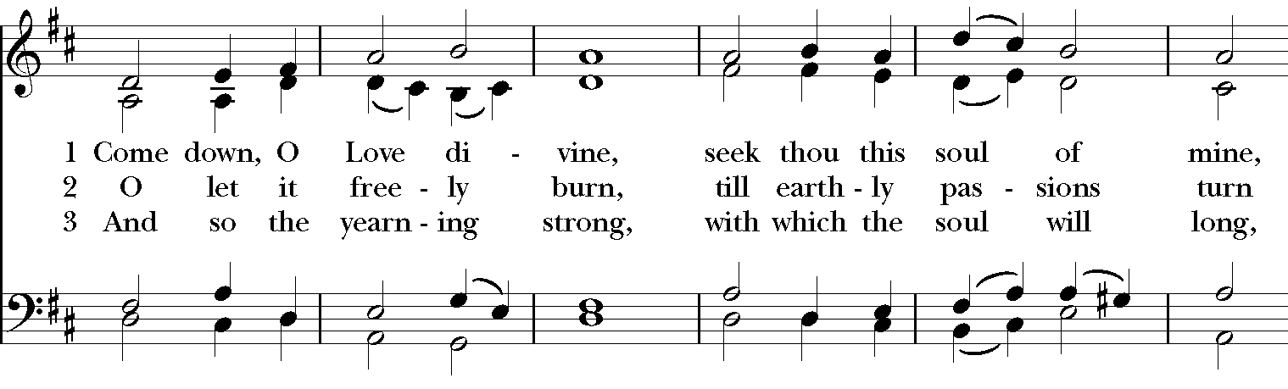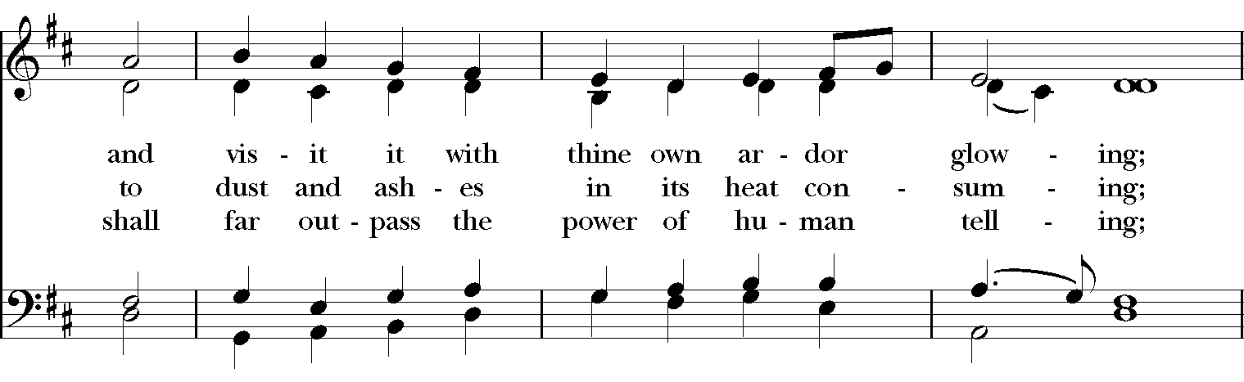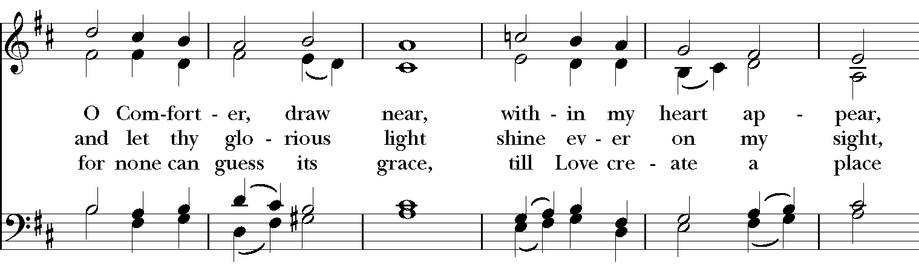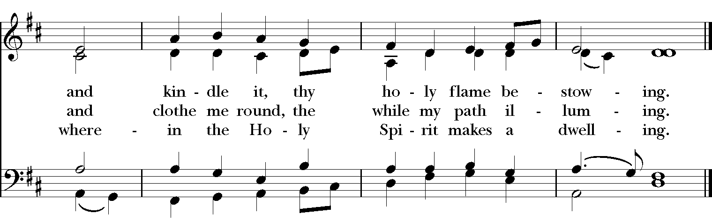

581 (vs1-3)
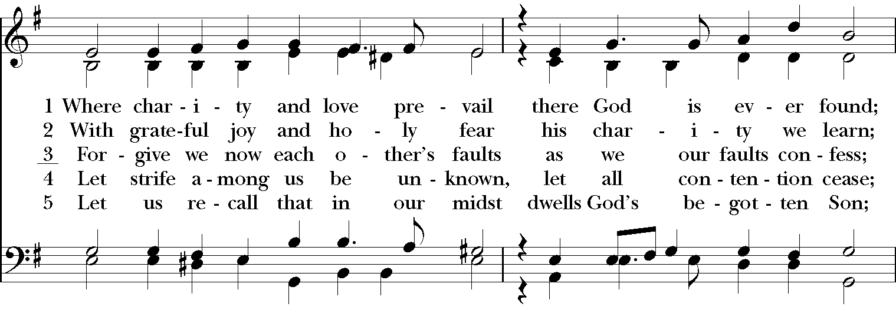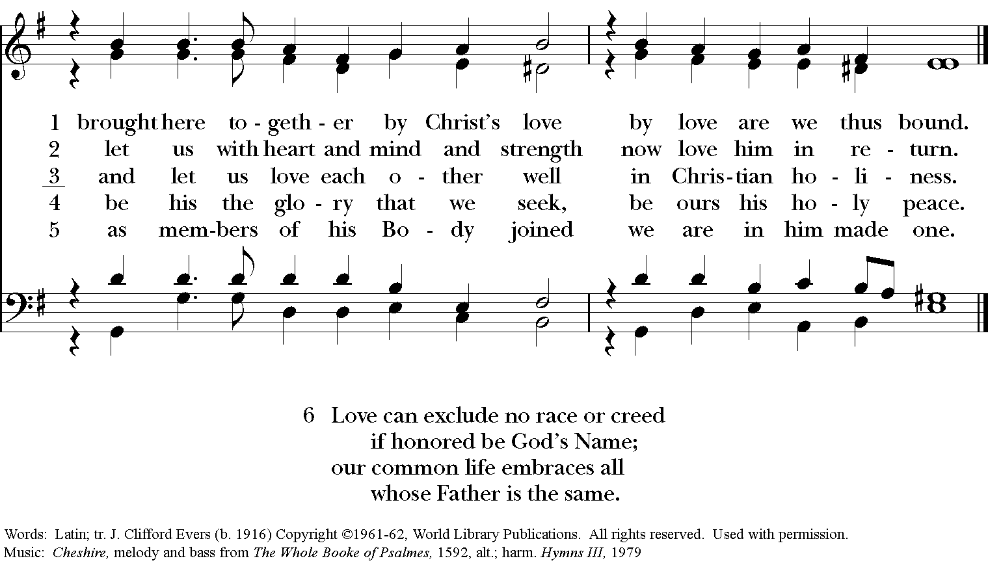
After Communion, the Presider says
Let us pray.
All
Eternal God, heavenly Father, you have graciously accepted us as living members of your Son our
Savior Jesus Christ, and you have fed us with spiritual food in the Sacrament of his Body and Blood.
Send us now into the world in peace, and grant us strength and courage to love and serve you
with gladness and singleness of heart; through Christ our Lord. Amen.

Blessing

Announcements

Dismissal
People | Thanks be to God.

Closing Hymn 397
